Sri Lanka Institute of Information

Technology



Lab Submission

<Lab sheet 09>

**<IT24101458>**

**<Sanvidu M.G.M.>**

**Probability and Statistics| IT2120**

B.Sc. (Hons) in Information Technology

Exercise

1. Assume that the time taken to bake a batch of cookies is normally distributed with mean 45 minutes and standard deviation of 2 minutes.

i. Generate a random sample of size 25 for the baking time.

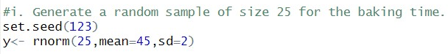



ii. Test whether the average baking time is less than 46 minutes at a 5% level of significance.



